Merry Christmas and Happy New Year 2008

MIDTOWNERS SUNSHINE OF THE WEEK ► December 28th, 2007
Birthday of Keya Banerjee, spouse of Rtn. Anandarup on December 24th
Birthday of Manju Eller, spouse of VP Navyo on December 29th

SPEAKER OF THE WEEK ► NO SPEAKER
THEME | Club Assembly
Please join the third club assembly for 2007-08 where we will approve the audited accounts and the incoming board for 2008-09. We will also discuss any other points our members want to raise.
The first Club Assembly was held on August 3rd, and the second when the DG visited our Club on Sept 21st.

UPCOMING SPEAKERS ► PREVIEW
DATE | SPEAKER | THEME
Jan 4th | Rtn. Hem Pokharel (RC Sudbury, USA) | Household Water Treatment Systems
Jan 11th | Dr. Saurav Dev Bhatta | Deadly sins of Statistical Misrepresentation in the Media
Jan 18th

THE MID-TOWN CLUB ► NEWS
TWO IN-HOUSE SPEAKERS
For the past two weeks, we had in-house speakers give talks on two very pertinent issues that our nation is currently facing. On December 14th, Rtn. Dr. Kali Bahadur Rokaya talked about the human rights situation in Nepal. He is currently a member of the Nepal Human Rights Commission. The following Friday on December 21st, Rtn. Radhesh Pant gave an interesting presentation full of facts and figures on the current status of economy and financial system with stress on opportunities and challenges in the financial sector.
CHARTER DAY CELEBRATIONS
Our Club celebrated its 18th Charter Day on November 24th with a fun-filled afternoon at garden in Wunjala Restaurant in Naxal. All together 26 members were joined by 15 spouses and guests and 4 Rotaracts at the sunny afternoon event that included door prize, bingo and auctions. The following Mid-Towners generously donated items for prizes and auction:

PP Ajaya | PP Ambica | PP Jyotsna | PP Niranjan
President Walter | PP Yogendra | VP Navyo | Rtn. Pramod
Rtn. Basu | PP Komal | Rtn. Neil

Rotary Art Competition 2007
On Friday December 28th, HE Mr. Sumith Nakandala, Ambassador of Sri Lanka will inaugurate the painting exhibition organized by our Club. The competition is the result of an art workshop that was arranged two weeks ago in Shuvatara School A total of 52 students (26 boys and 26 girls) from 25 secondary schools participated in the Competition. All the paintings are on sale to highest bidders. The minimum bid for a painting is suggested to be Rs 500. The visitors are requested to provide encouragement to the students by buying the paintings. The exhibition will continue on 29 and 30 December from 10:30 a.m. to 4:30 p.m.
Sponsor of cash awards was provided by Sharada Chitracar in memory of late Tejbahadur Chitrakar, Art Teacher and a pioneer of contemporary art in Nepal. Prizes - I: Rs 4,000, II Prize: Rs 2,500, III Prize Rs 1,500, and 4 Consolation Prizes: Rs 500 each.
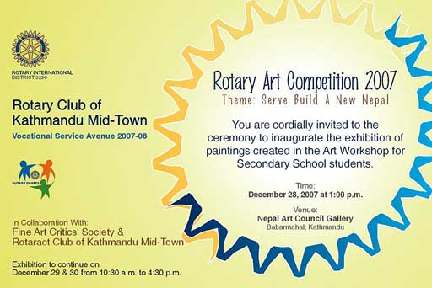
Program Detail
- Welcome: Rtn Saroj Shrestha, Chairman, Program Organizing Committee
- Report of the Art Workshop: Mrs. Sharada Chitrakar, Program Coordinator
- Comments by Rtn. Ramesh Khanal, President, Lalitkala Samikshyak Samaj
- Appreciation of the Program: DGN Rtn Ratna Man Shakya
- Address: Chief Guest, HE Mr. Sumith Nakandala, Ambassador of Sri Lanka
- Distribute Certificates and Awards: Chief Guest
- Vote of thanks by President Rtn Walter Diller, RC Ktm MT
- Chief Guest to open the exhibition for public view
Refreshment and Tea

THE ROTARY INTERNATIONAL ► NEWS
John Kenny declared official nominee for 2009-10 RI president
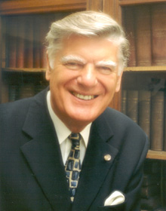
On 1 December 2007, President Wilfrid J. Wilkinson declared John Kenny to be the official nominee for president of Rotary International in 2009-10. Rotarian Kenny’s formal election will take place at the 2008 Los Angeles Convention. John Kenny, of the Rotary Club of Grangemouth Central, Scotland, is a past dean of his local law faculty, a judge, and a notary. A Rotarian since 1970, Kenny served Rotary International in Great Britain and Ireland as president and vice president. He has served RI as director, executive committee chair, Rotary Foundation trustee, institute moderator, district governor, convention vice chair and group leader, president’s representative, and committee member and chair. He’s been a delegate, member at large, and parliamentarian at several Councils on Legislation. Kenny is a Major Donor to The Rotary Foundation and a Bequest Society member and has received the Foundation’s Citation for Meritorious Service and Distinguished Service Award.

Editor: Rabi Karmacharya, Club Service Director email: rabikarma@gmailcom

----- Original Message -----
From: Rabi Karmacharya
To: Rabi Karmacharya
Sent: 27 December, 2007 9:23
Subject: BC Vol 15 07-08

Dear Mid-Towners.
Wishing you all a Merry Christmas and Happy New Year 2008. Hope the new year brings peace and prosperity to all.
Please note that we have our CLUB ASSEMBLY tomorrow.
YIR,
Rabi
CSD 2007-09
RC KTM Mid-Town

